ICS 233 Homework Assignment 05 Version 02 – Term 192

**Instructions**: Submit in the ICS 233 Common Blackboard a .zip file containing a word or pdf file.

Name the zip file in the format:

**SectionNumber_KFUPM ID_HW05.zip (Example: 02_970000000_HW04.zip)**

by **11: 59 pm on Saturday 4th April 2020.**

**Note: A submission that does not follow the submission instructions will not be graded.**

**Note:** For each of the following questions **show detailed steps and provide instruction format diagrams**.

**1.** [8 points: 4 + 4] Give the two encodings for the instruction: **TEST AL, AH**

1. 84E0H
2. 86C4H

**2.**  [10 points] Encode the instruction: **MOV DX, ES:[BP]**

268B5600H

**3.** [10 points]Encode the instruction: **XOR BX, SS:[0A742H]**

36311E42A7

**4.** [10 points]Encode the instruction: **ADD [SI + 82H], BX**

015C83H

**5.** [10 points]Encode the instruction **CMP [EBP], ESI**

397500

6. [12 points: 10 + 2]Encode the instruction: **SUB EDI, [ESI + 8 * ECX + 254637H]**

(a) If the machine mode is 32-bits

2BBCCE37462500H

(b) If the machine mode is 16-bits

67662BBCCE37462500H

7. [10 points]Encode the instruction **ADD ECX, [4 * EDX + 4352H]**

030C9552430000H

8. [10 points: 7 + 3](a)Assuming 32-bit mode,decode the instruction0000001111010001B

(b) What encoding is equivalent to the encoding in 8(a) ?

A add edx, ecx

B 01CAH

9. [10 point]Assuming 16-bit mode, decode the instruction **10001011001101100110101101110010B**

mov si, ds:[726bH]

10. [10 points]Given thatthe instruction:

**MOV reg/mem, immediate**

has the format:

**1100 011w MOD 000 R/M displacementLow displacementHigh immediate**

Encode the instruction:

**MOV WORD PTR [BX + SI + 4264H], 86H**

C78064428600H

**x86 INSTRUCTION ENCODING AND DECODING TABLES**

|  |  |
| --- | --- |
|  |  |

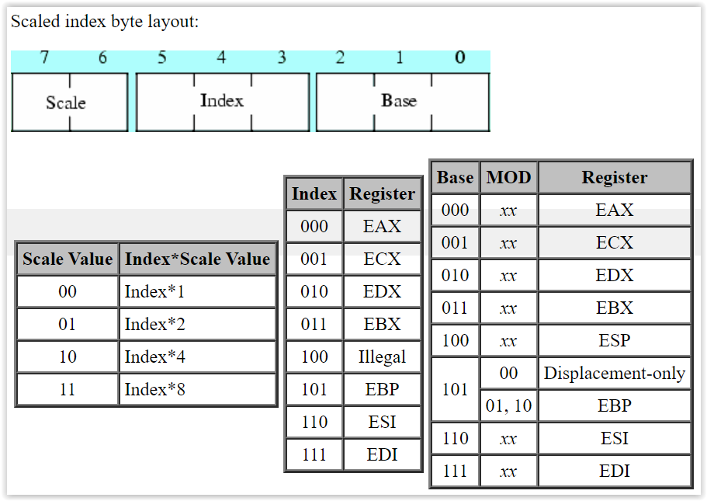

**REG field**

|  |  |
| --- | --- |
| Register | Register code |
| EAX / AX / AL / **ES** | 000 |
| EBX / BX / BL / **DS** | 011 |
| ECX / CX / CL / **CS** | 001 |
| EDX / DX / DL / **SS** | 010 |
| ESP / SP / AH | 100 |
| EBP / BP / CH | 101 |
| ESI / SI / DH | 110 |
| EDI / DI / BH | 111 |

**16-bit MOD R/M byte and addressing modes:**

|  |  |  |  |  |  |
| --- | --- | --- | --- | --- | --- |
| **MOD**  **R/M** | **00** | **01** | **10** | **11** | |
|  |  |  |  | W = 0 | W = 1 |
| **000** | [BX + SI] | [BX + SI + disp8] | [BX + SI + disp16] | AL | AX |
| **001** | [BX + DI] | [BX + DI + disp8] | [BX + DI + disp16] | CL | CX |
| **010** | [BP + SI] | [BP + SI + disp8] | [BP + SI + disp16] | DL | DX |
| **011** | [BP + DI] | [BP + DI + disp8] | [BP + DI + disp16] | BL | BX |
| **100** | [SI] | [SI + disp8] | [SI + disp16] | AH | SP |
| **101** | [DI] | [DI + disp8] | [DI + disp16] | CH | BP |
| **110** | [disp16] | [BP + disp8] | [BP + disp16] | DH | SI |
| **111** | [BX] | [BX + disp8] | [BX + disp16] | BH | DI |

**32-bit MOD R/M byte and addressing modes:**

|  |  |  |  |  |  |
| --- | --- | --- | --- | --- | --- |
| **MOD**  **R/M** | **00** | **01** | **10** | **11** | |
|  |  |  |  | W = 0 | W = 1 |
| **000** | [EAX] | [EAX + disp8] | [EAX + disp32] | AL | EAX |
| **001** | [ECX] | [ECX + disp8] | [ECX + disp32] | CL | ECX |
| **010** | [EDX] | [EDX + disp8] | [EDX + disp32] | DL | EDX |
| **011** | [EBX] | [EBX + disp8] | [EBX + disp32] | BL | EBX |
| **100** | [Scaled index] | [Scaled index + disp8] | [Scaled index + disp32] | AH | ESP |
| **101** | [disp32] | [EBP + disp8] | [EBP + disp32] | CH | EBP |
| **110** | [ESI] | [ESI + disp8] | [ESI + disp32] | DH | ESI |
| **111** | [EDI] | [EDI + disp8] | [EDI + disp32] | BH | EDI |